Effects Signals
In this exercise, you will
- Appreciate what effects are
- Know when to use effects/ and when not to
- Be able to differentiate effects from computed signals
- Know how to use effects safely in Angular components
In real applications, we often must react to state changes. For example,
- Logging the state value
- Triggering analytics
- Calling imperative API
These are side effects. Not just about calculating the new state values.
Effect signals are functions that will run if any of the dependence signals changed. Unlike writable and computed signals, effect signals do not return any value.
We can’t call the effects explicitly. Angular will handle for us.

Exercise Steps:
- Create a new application with name Ex07 in Angular folder using same settings as Ex06.
- Open the application in VS Code
- Add new component math
- In src/app.ts, import the math component
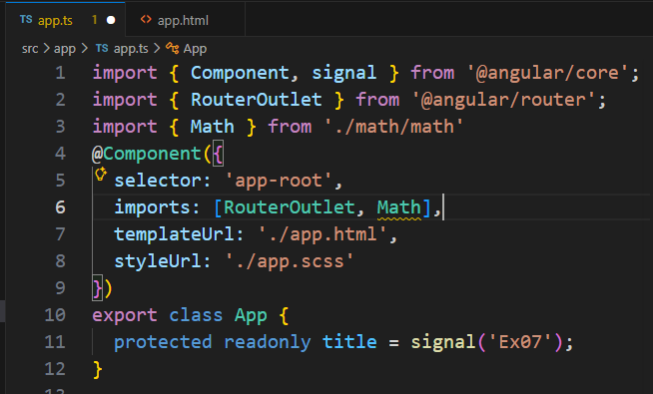
- In src/app.html
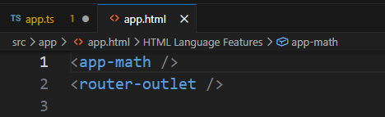

- In src/app/math/math.ts
import { Component, signal, computed, effect } from '@angular/core';

@Component({
selector: 'app-math',
imports: [],
templateUrl: './math.html',
styleUrl: './math.scss',
})
export class Math {
static GCD(x:number, y:number):number{
while (y!=0){
let oldX:number = x;
x = y;
y = oldX % y;
}
return x;
}
static LCM(x:number,y:number):number{
return (x*y)/this.GCD(x, y);
}
protected x = signal(1);
protected y = signal(1);
protected gcd = computed(()=>Math.GCD(this.x(),this.y()))
protected lcm = computed(()=>Math.LCM(this.x(),this.y()))

protected increaseX():void{
this.x.update(v=>v+1);
}
protected increaseY():void{
this.y.update(v=>v+1);
}
protected decreaseX():void{
this.x.update(v=>v>1?v-1:v)
}
protected decreaseY():void{
this.y.update(v=>v>1?v-1:v)
}

//The effects
private xChanged = effect(()=>console.log('x:' + this.x()))
private yChanged = effect(()=>console.log('y:' + this.y()))
private xyChanged = effect(()=>console.log('x:' + this.x() + ' y:' + this.y()))
}

- In src/app/math/math.html
<table border="1">
<tr><th>{{x()}}</th><th>{{y()}}</th></tr>
<tr>
<td>
<button (click)="increaseX()">+</button>
<button (click)="decreaseX()">-</button>
</td>
<td>
<button (click)="increaseY()">+</button>
<button (click)="decreaseY()">-</button>
</td>
</tr>
<tr><td colspan="2">GCD: {{gcd()}}</td></tr>
<tr><td colspan="2">LCM: {{lcm()}}</td></tr>
</table>

- Save all files and run the application from terminal using ng serv –open --port 8888
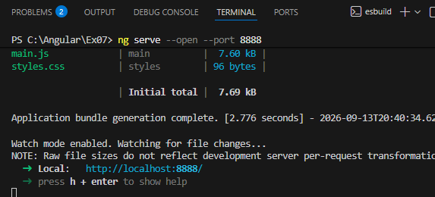
- In the web browser, press F12 key, then select Console tab
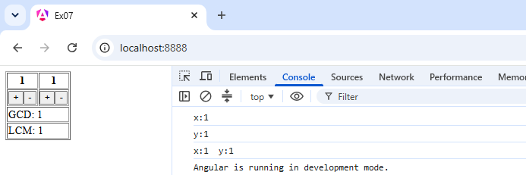
Try to click buttons and observe the changes
- Close VS Code

